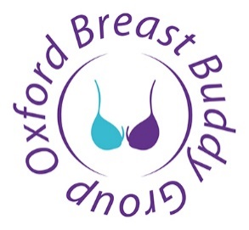

Thank you for choosing to donate to OBBG (Oxford Breast Buddy Group). Under the Git Aid Scheme, we will receive an extra 25p for every £1 you donate at no extra cost to you. Please fill in the short form below to make your Gift Aid declaration.

Charity Gift Aid Declaration – single donation

In order to Gift Aid your donation you must tick the box below:
I want to Gift Aid my donation of £______________ to:

Name of Charity: Oxford Breast Buddy Group
Registered Charity Number: 1166891
I am a UK taxpayer and understand that if I pay less Income Tax and/or Capital Gains Tax in the current tax year than the amount of Gift Aid claimed on all my donations it is my responsibility to pay any difference.
Please note that your address is needed to identify you as a current UK tax payer.

Your details:

Title ___________ First name or initial(s) _____________

Surname ______________________________________________________________________________________

Full home address ______________________________________________________________________________

__________________________________Postcode ____________________________________________________

Date ___________________________________

Please notify the charity if you:

- want to cancel this declaration
- change your name or home address
- no longer pay sufficient tax on your income and/or capital gains

Note to higher rate taxpayers

If you pay Income Tax at the higher or additional rate and want to receive the additional tax relief due to you, you must include all your Gift Aid donations on your Self-Assessment tax return or ask HM Revenue and Customs to adjust your tax code.

